SEQUENCING ASSIGNMENT

PROJECT 1

Create a Precedence Diagramming Method (PDM) network diagram based on the following information to determine (a) ES, LS, EF and LF for each activity; (b) slack for each activity; (c) the sequence of activities that make up the Critical Path; and (d) the total number of days for the project. There are 10 activities A through J.

Durations:

* Activities A, B, and H have durations of 5 days.
* Activities C, E, I, and J have durations of 6 days.
* Activities D, F, and G have durations of 7 days.

Predecessors:

* Activity C must precede Activity B.
* Activities A and F must precede Activity E.
* Activity E must precede Activity G.
* Activities B and D must precede Activities H and I, respectively.
* Activities G, H, and I may be conducted in parallel.
* Activities G, H, and I precede Activity J.

My initial PDM network diagram is showed below:

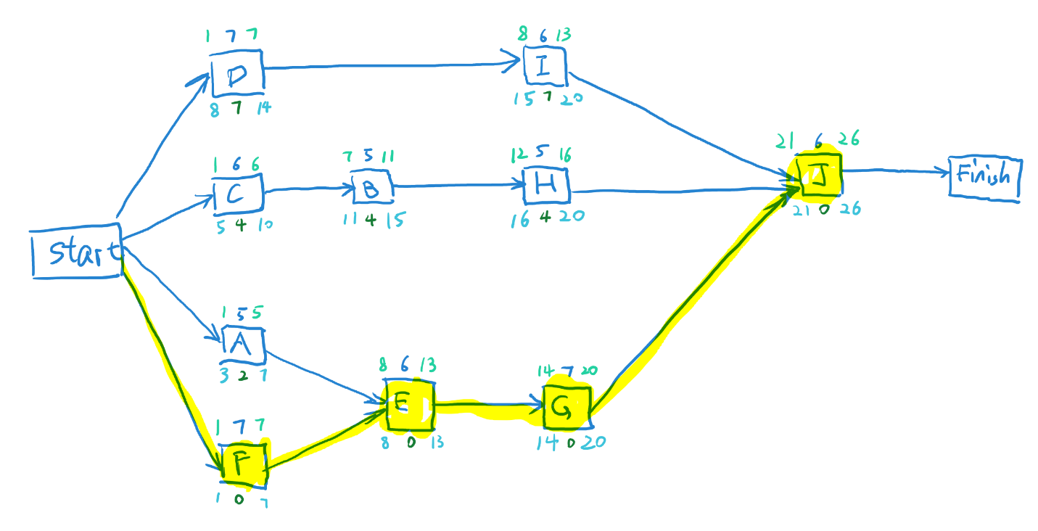

Below is information for ES, LS, EF, LF and slack for each activity:

|  |  |  |  |  |  |  |  |  |
| --- | --- | --- | --- | --- | --- | --- | --- | --- |
| Activity Name | Predecessor | Duration | Slack | ES | LS | EF | LF | Units |
| A |  | 5 | 2 | 1 | 3 | 5 | 7 | day(s) |
| B | C | 5 | 4 | 7 | 11 | 11 | 15 | day(s) |
| C |  | 6 | 4 | 1 | 5 | 6 | 10 | day(s) |
| D |  | 7 | 7 | 1 | 8 | 7 | 14 | day(s) |
| E | A, F | 6 | 0 | 8 | 8 | 13 | 13 | day(s) |
| F |  | 7 | 0 | 1 | 1 | 7 | 7 | day(s) |
| G | E | 7 | 0 | 14 | 14 | 20 | 20 | day(s) |
| H | B | 5 | 4 | 12 | 16 | 16 | 20 | day(s) |
| I | D | 6 | 7 | 8 | 15 | 13 | 20 | day(s) |
| J | G, H, I | 6 | 0 | 21 | 21 | 26 | 26 | day(s) |

The sequence of activities that make up the Critical Path is:

F-E-G-J

The total number of days for project 1 is 26 days.

PROJECT 2

Create a Precedence Diagramming Method (PDM) network diagram based on the following information to determine (a) ES, LS, EF and LF for each activity; (b) slack for each activity; (c) the sequence of activities that make up the Critical Path; and (d) the total number of days for the project. There are 10 activities K through T.

Durations:

* Activity K has a duration of 6 days.
* Activities L, P, and T have durations of 7 days.
* Activity M has a duration of 5 days.
* Activity N has a duration of 8 days.
* Activity O has a duration of 4 days.
* Activity Q has a duration of 7 days.
* Activity R has a duration of 3 days.
* Activity S has a duration of 8 day.

Predecessors:

* Activity K must precede Activity M.
* Activities L must precede Activities N and O.
* Activity N must precede Activities Q and S.
* Activity O must precede Activity P.
* Activities N and P must precede Activity Q.
* Activities M and Q must precede Activity R.
* Activities N and P must precede Activity S.
* Activities R and S must precede Activity T.

My initial PDM network diagram is showed below:

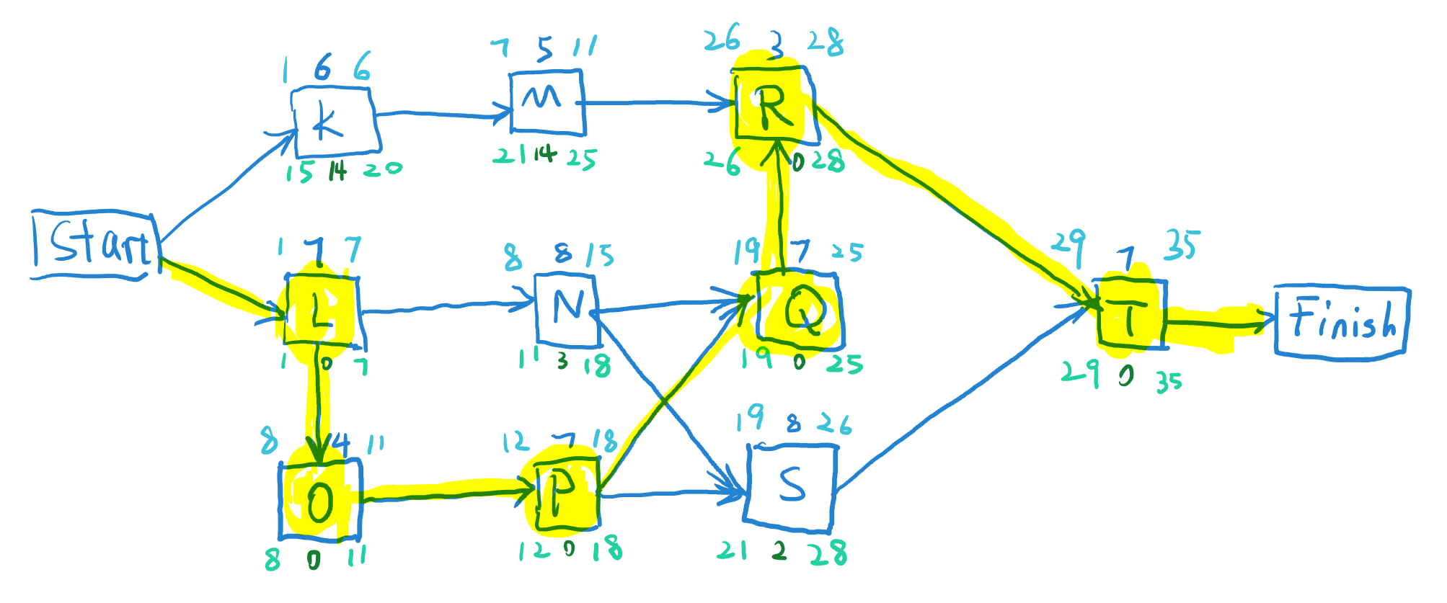

Below is information for ES, LS, EF, LF and slack for each activity:

|  |  |  |  |  |  |  |  |  |
| --- | --- | --- | --- | --- | --- | --- | --- | --- |
| Activity Name | Predecessor | Duration | Slack | ES | LS | EF | LF | Units |
| K |  | 6 | 14 | 1 | 15 | 6 | 20 | day(s) |
| L |  | 7 | 0 | 1 | 1 | 7 | 7 | day(s) |
| M | K | 5 | 14 | 7 | 21 | 11 | 25 | day(s) |
| N | L | 8 | 3 | 8 | 11 | 15 | 18 | day(s) |
| O | L | 4 | 0 | 8 | 8 | 11 | 11 | day(s) |
| P | O | 7 | 0 | 12 | 12 | 18 | 18 | day(s) |
| Q | N, P | 7 | 0 | 19 | 19 | 25 | 25 | day(s) |
| R | M, Q | 3 | 0 | 26 | 26 | 28 | 28 | day(s) |
| S | N, P | 8 | 2 | 19 | 21 | 26 | 28 | day(s) |
| T | R, S | 7 | 0 | 29 | 29 | 35 | 35 | day(s) |

The sequence of activities that make up the Critical Path is:

L-O-P-Q-R-T

The total number of days for project 2 is 35 days.

PROJECT 3

Given the Expected Duration (ED), calculate the Early-Start (ES), Early-Finish (EF), Late-Start (LS), Late-Finish (LF) times, and Total Slack (TS) for each activity as depicted in figure [Assignment-Sequencing-Project-3.pdfPreview the document](https://fiu.instructure.com/courses/47790/files/7004438/download?wrap=1). Determine (a) ES, LS, EF and LF for each activity; (b) slack for each activity; (c) the sequence of activities that make up the Critical Path; and (d) the total number of days for the project.

My initial PDM network diagram is showed below:

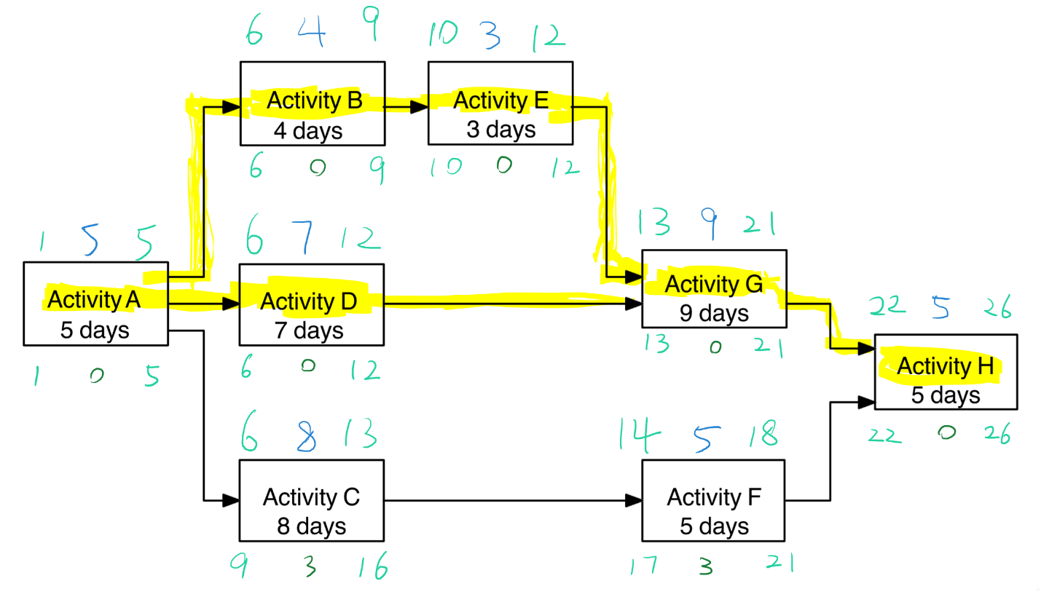

Below is information for ES, LS, EF, LF and slack for each activity:

|  |  |  |  |  |  |  |  |  |
| --- | --- | --- | --- | --- | --- | --- | --- | --- |
| Activity Name | Predecessor | Duration | Slack | ES | LS | EF | LF | Units |
| A |  | 5 | 0 | 1 | 1 | 5 | 5 | day(s) |
| B | A | 4 | 0 | 6 | 6 | 9 | 9 | day(s) |
| C | A | 8 | 3 | 6 | 9 | 13 | 16 | day(s) |
| D | A | 7 | 0 | 6 | 6 | 12 | 12 | day(s) |
| E | B | 3 | 0 | 10 | 10 | 12 | 12 | day(s) |
| F | C | 5 | 3 | 14 | 17 | 18 | 21 | day(s) |
| G | E, D | 9 | 0 | 13 | 13 | 21 | 21 | day(s) |
| H | G, F | 5 | 5 | 22 | 22 | 26 | 26 | day(s) |

The sequence of activities that make up the Critical Path is:

A-B-E-G-H and A-D-G-H

The total number of days for project 3 is 26 days.

PROJECT 4

Given the Expected Duration (ED), calculate the Early-Start (ES), Early-Finish (EF), Late-Start (LS), Late-Finish (LF) times, and Total Slack (TS) for each activity as depicted in figure [Assignment-Sequencing-Project-4.pdfPreview the document](https://fiu.instructure.com/courses/47790/files/7004440/download?wrap=1). Determine (a) ES, LS, EF and LF for each activity; (b) slack for each activity; (c) the sequence of activities that make up the Critical Path; and (d) the total number of days for the project.

My initial PDM network diagram is showed below:

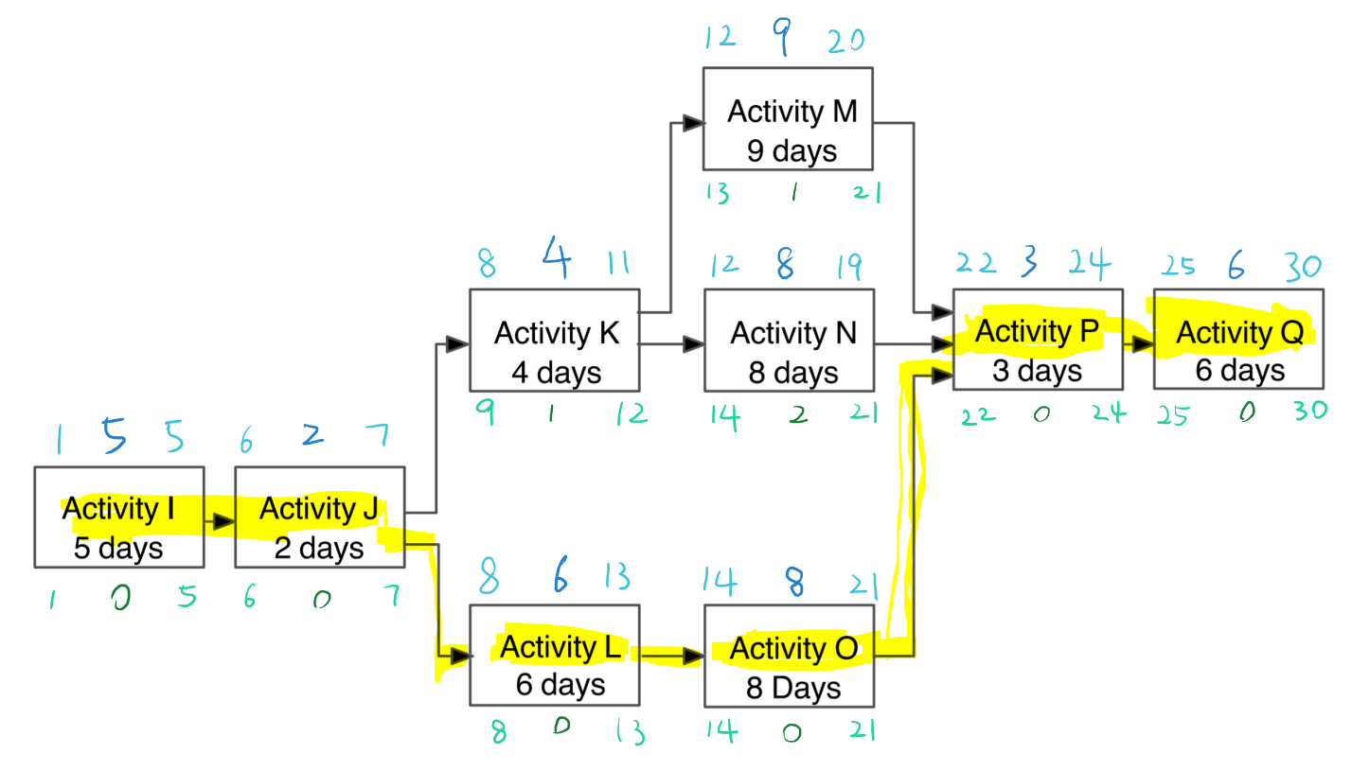

Below is information for ES, LS, EF, LF and slack for each activity:

|  |  |  |  |  |  |  |  |  |
| --- | --- | --- | --- | --- | --- | --- | --- | --- |
| Activity Name | Predecessor | Duration | Slack | ES | LS | EF | LF | Units |
| I |  | 5 | 0 | 1 | 1 | 5 | 5 | day(s) |
| J | I | 2 | 0 | 6 | 6 | 7 | 7 | day(s) |
| K | J | 4 | 1 | 8 | 9 | 11 | 12 | day(s) |
| L | J | 6 | 0 | 8 | 8 | 13 | 13 | day(s) |
| M | K | 9 | 1 | 12 | 13 | 20 | 21 | day(s) |
| N | K | 8 | 2 | 12 | 14 | 19 | 21 | day(s) |
| O | L | 8 | 0 | 14 | 14 | 21 | 21 | day(s) |
| P | M, N, O | 3 | 0 | 22 | 22 | 24 | 24 | day(s) |
| Q | P | 6 | 0 | 25 | 25 | 30 | 30 | day(s) |

The sequence of activities that make up the Critical Path is:

I-J-L-O-P-Q

The total number of days for project 4 is 30 days.